MACH4METAL

metalworking machinery
Transito 21, 6909 DA Babberich, Netherlands
Tel. + 31 (0)316 – 247123
Fax. + 31 (0)316 - 247956
info@mach4metal.com

Bank No : 66.52.13.883
IBAN : NL33 INGB 0665 2138 83
BIC : INGBNL2A
VAT : NL 815393635B01

DMG GILDEMEISTER CTX 510 eco

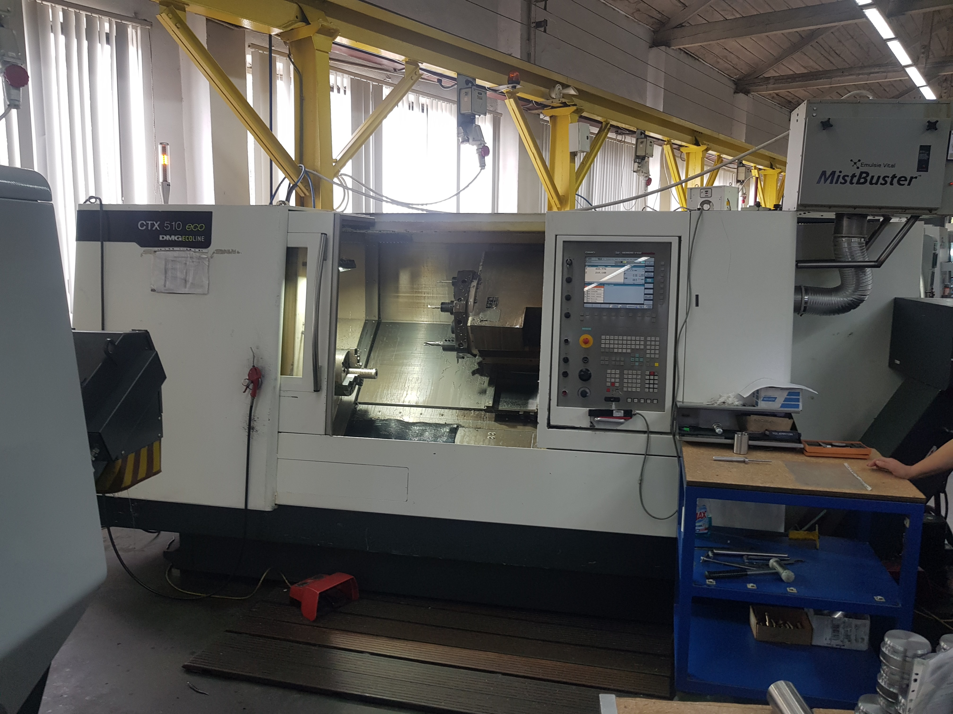
- Make : DMG Gildemeister
- Type : CTX 510 eco
- Serial : 8045 000083E
- YOP : 2009

- Swing over slide : 680
- Swing over bed : 465
- DBC turning length : 1.050
- Spindle bore : 76

- Travel X slide : 300
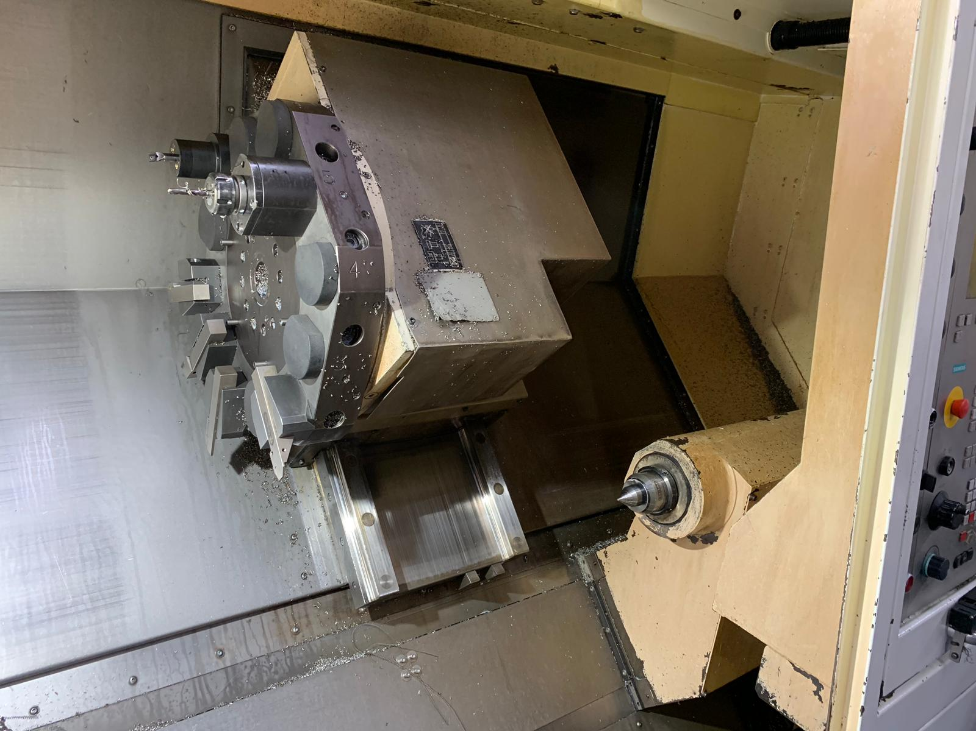
- Travel Z slide : 1.050
- Travel C index : 0.001 Gr

- Chuck Ø :
- Spindle speeds : 4000
- Power kW : 42
- Quill : 120
- Quill travel : 150
- Quill taper : Mk 5

- Revolver VDi40 : 12 Duplomatic
- Live tools : 7.5 kW
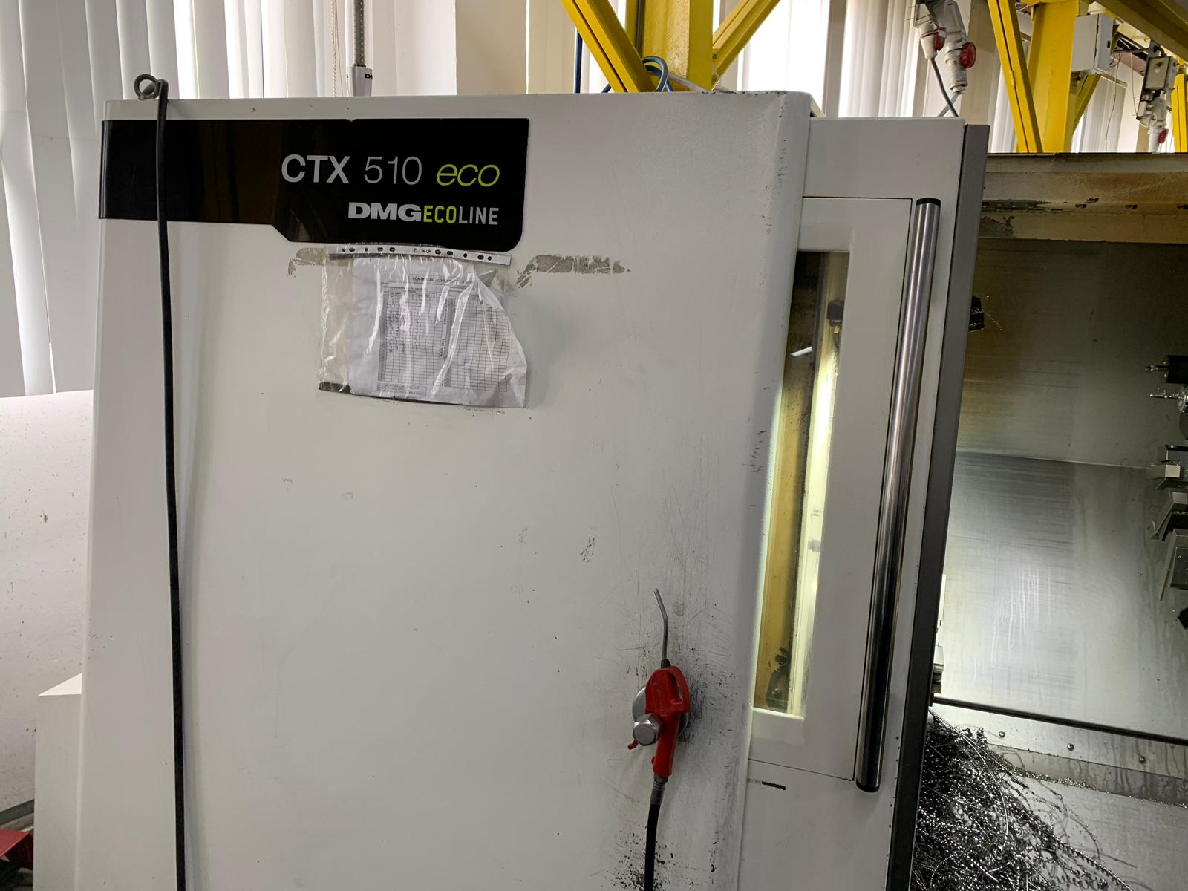
- Speeds : 4.000 Rpm

- Dimensions
- Length : 4.665
- Width : 1.700
- Height : 1.965
- Weight : 8.100

- Chip conveyor
- Live Vdi 40 driven tools

Please Note: The above information has been obtained to the best of our ability and belief from, and from the manufacturers where possible. It is given in good faith, but its accuracy can not be guaranteed. Accordingly, it will not form a representation or constitute contractual terms. We advise you to check any vital details!

